# **Name: Abdurrahman Qureshi**

# **Roll No: 210451**

Practical No: 22

1. Write a Program to use Fragments

Sidebar.xml

<?xml version="1.0" encoding="utf-8"?>  
<LinearLayout xmlns:android="http://schemas.android.com/apk/res/android"  
 xmlns:tools="http://schemas.android.com/tools"  
 android:layout_width="wrap_content"  
 android:layout_height="match_parent"  
 tools:context=".Sidebar"  
 android:orientation="vertical"  
 android:background="@color/secondary_background_color"  
 android:layout_marginTop="50dp"  
 android:padding="10dp"  
 android:id="@+id/sidebarContainer"  
 >  
 <TextView  
 android:id="@+id/goToAccount"  
 android:textColor="@color/secondary_text_color"  
 android:layout_width="125dp"  
 android:layout_height="wrap_content"  
 android:text="Account"  
 android:textSize="25sp"  
 tools:ignore="HardcodedText" />  
 <TextView  
 android:textColor="@color/secondary_text_color"  
 android:layout_width="125dp"  
 android:layout_height="wrap_content"  
 android:text=""  
 android:textSize="25sp"  
 tools:ignore="HardcodedText" />  
 <TextView  
 android:id="@+id/goToAddArticle"  
 android:textColor="@color/secondary_text_color"  
 android:layout_width="125dp"  
 android:layout_height="wrap_content"  
 android:text="Add Article"  
 android:textSize="25sp"  
 tools:ignore="HardcodedText" />  
 <TextView  
 android:textColor="@color/secondary_text_color"  
 android:layout_width="125dp"  
 android:layout_height="wrap_content"  
 android:text=""  
 android:textSize="25sp"  
 tools:ignore="HardcodedText" />  
 <TextView  
 android:id="@+id/goToLogOut"  
 android:textColor="@color/secondary_text_color"  
 android:layout_width="125dp"  
 android:layout_height="wrap_content"  
 android:text="Log Out"  
 android:textSize="25sp"  
 tools:ignore="HardcodedText" />  
</LinearLayout>

Navbar.xml

<?xml version="1.0" encoding="utf-8"?>  
<LinearLayout xmlns:android="http://schemas.android.com/apk/res/android"  
 xmlns:tools="http://schemas.android.com/tools"  
 android:layout_width="match_parent"  
 android:layout_height="match_parent"  
 android:orientation="horizontal"  
 tools:context=".Navbar">  
 <TextView  
 android:id="@+id/navbarTrigger"  
 android:layout_width="0dp"  
 android:layout_height="wrap_content"  
 android:layout_weight="1"  
 android:text="="  
 android:textSize="30sp"  
 android:textAlignment="center"  
 android:background="@color/primary_background_color"  
 android:textColor="@color/primary_text_color"  
 tools:ignore="HardcodedText" />  
 <TextView  
 android:id="@+id/appTitle"  
 android:layout_width="0dp"  
 android:layout_height="wrap_content"  
 android:layout_weight="4"  
 android:text=" newZ feZt"  
 android:textSize="30sp"  
 android:textAlignment="textStart"  
 android:background="@color/primary_background_color"  
 android:textColor="@color/primary_text_color"  
 tools:ignore="HardcodedText" />  
</LinearLayout>

MainActivity.xml:

<?xml version="1.0" encoding="utf-8"?>  
<LinearLayout xmlns:android="http://schemas.android.com/apk/res/android"  
 xmlns:app="http://schemas.android.com/apk/res-auto"  
 xmlns:tools="http://schemas.android.com/tools"  
 android:id="@+id/main"  
 android:layout_width="match_parent"  
 android:layout_height="match_parent"  
 tools:context=".MainActivity"  
 android:orientation="vertical">  
 <fragment  
 android:id="@+id/navbarFragment"  
 android:layout_width="match_parent"  
 android:layout_height="wrap_content"  
 android:name="com.example.newz_fezt.Navbar"  
 />  
 <fragment  
 android:id="@+id/sidebarFragment"  
 android:layout_width="wrap_content"  
 android:layout_height="match_parent"  
 android:visibility="invisible"  
 android:name="com.example.newz_fezt.Sidebar"  
 />  
</LinearLayout>

Sidebar.java:

package com.example.newz_fezt;  
  
import android.os.Bundle;  
  
import androidx.fragment.app.Fragment;  
  
import android.view.LayoutInflater;  
import android.view.View;  
import android.view.ViewGroup;  
import android.widget.TextView;  
  
*/**  
 * A simple {@link Fragment} subclass.  
 * Use the {@link Sidebar#newInstance} factory method to  
 * create an instance of this fragment.  
 */*public class Sidebar extends Fragment {  
  
 *// TODO: Rename parameter arguments, choose names that match  
 // the fragment initialization parameters, e.g. ARG_ITEM_NUMBER* private static final String *ARG_PARAM1* = "param1";  
 private static final String *ARG_PARAM2* = "param2";  
  
 *// TODO: Rename and change types of parameters* private String mParam1;  
 private String mParam2;  
  
 public Sidebar() {  
 *// Required empty public constructor* }  
  
 */**  
 * Use this factory method to create a new instance of  
 * this fragment using the provided parameters.  
 *  
 * @param param1 Parameter 1.  
 * @param param2 Parameter 2.  
 * @return A new instance of fragment Sidebar.  
 */  
 // TODO: Rename and change types and number of parameters* public static Sidebar newInstance(String param1, String param2) {  
 Sidebar fragment = new Sidebar();  
 Bundle args = new Bundle();  
 args.putString(*ARG_PARAM1*, param1);  
 args.putString(*ARG_PARAM2*, param2);  
 fragment.setArguments(args);  
 return fragment;  
 }  
  
 @Override  
 public void onCreate(Bundle savedInstanceState) {  
 super.onCreate(savedInstanceState);  
 if (getArguments() != null) {  
 mParam1 = getArguments().getString(*ARG_PARAM1*);  
 mParam2 = getArguments().getString(*ARG_PARAM2*);  
 }  
 }  
  
 @Override  
 public View onCreateView(LayoutInflater inflater, ViewGroup container,  
 Bundle savedInstanceState) {  
 *// Inflate the layout for this fragment* return inflater.inflate(R.layout.*fragment_sidebar*, container, false);  
 }  
}

Navbar.java:

package com.example.newz_fezt;  
  
import android.os.Bundle;  
  
import androidx.fragment.app.Fragment;  
  
import android.view.LayoutInflater;  
import android.view.View;  
import android.view.ViewGroup;  
  
*/**  
 * A simple {@link Fragment} subclass.  
 * Use the {@link Navbar#newInstance} factory method to  
 * create an instance of this fragment.  
 */*public class Navbar extends Fragment {  
  
 *// TODO: Rename parameter arguments, choose names that match  
 // the fragment initialization parameters, e.g. ARG_ITEM_NUMBER* private static final String ARG_PARAM1 = "param1";  
 private static final String ARG_PARAM2 = "param2";  
  
 *// TODO: Rename and change types of parameters* private String mParam1;  
 private String mParam2;  
  
 public Navbar() {  
 *// Required empty public constructor* }  
  
 */**  
 * Use this factory method to create a new instance of  
 * this fragment using the provided parameters.  
 *  
 * @param param1 Parameter 1.  
 * @param param2 Parameter 2.  
 * @return A new instance of fragment Sidebar.  
 */  
 // TODO: Rename and change types and number of parameters* public static Navbar newInstance(String param1, String param2) {  
 Navbar fragment = new Navbar();  
 Bundle args = new Bundle();  
 args.putString(ARG_PARAM1, param1);  
 args.putString(ARG_PARAM2, param2);  
 fragment.setArguments(args);  
 return fragment;  
 }  
  
 @Override  
 public void onCreate(Bundle savedInstanceState) {  
 super.onCreate(savedInstanceState);  
 if (getArguments() != null) {  
 mParam1 = getArguments().getString(ARG_PARAM1);  
 mParam2 = getArguments().getString(ARG_PARAM2);  
 }  
 }  
  
 @Override  
 public View onCreateView(LayoutInflater inflater, ViewGroup container,  
 Bundle savedInstanceState) {  
 *// Inflate the layout for this fragment* return inflater.inflate(R.layout.fragment_navbar, container, false);  
 }  
}

MainActivity.java:

package com.example.newz_fezt;  
  
import android.os.Bundle;  
import android.util.Log;  
import android.view.View;  
import android.view.ViewGroup;  
import android.widget.TextView;  
import android.widget.Toast;  
  
import androidx.activity.EdgeToEdge;  
import androidx.appcompat.app.AppCompatActivity;  
import androidx.core.graphics.Insets;  
import androidx.core.view.ViewCompat;  
import androidx.core.view.WindowInsetsCompat;  
  
public class MainActivity extends AppCompatActivity {  
  
 @Override  
 protected void onCreate(Bundle savedInstanceState) {  
 super.onCreate(savedInstanceState);  
 EdgeToEdge.*enable*(this);  
 setContentView(R.layout.*activity_main*);  
  
 ViewGroup sidebarFragment = findViewById(R.id.*sidebarFragment*);  
 TextView navbarTrigger = findViewById(R.id.*navbarTrigger*);  
 TextView goToAccount = findViewById(R.id.*goToAccount*);  
 TextView goToAddArticle = findViewById(R.id.*goToAddArticle*);  
 TextView goToLogOut = findViewById(R.id.*goToLogOut*);  
 ViewCompat.*setOnApplyWindowInsetsListener*(findViewById(R.id.*main*), (v, insets) -> {  
 Insets systemBars = insets.getInsets(WindowInsetsCompat.Type.*systemBars*());  
 v.setPadding(systemBars.left, systemBars.top, systemBars.right, systemBars.bottom);  
 return insets;  
 });  
 navbarTrigger.setOnClickListener(new View.OnClickListener() {  
 @Override  
 public void onClick(View v) {  
 try {  
 if (*sidebarFragment* != null) {  
 if (*sidebarFragment*.getVisibility() == View.*INVISIBLE*) {  
 *sidebarFragment*.setVisibility(View.*VISIBLE*);  
 } else {  
 *sidebarFragment*.setVisibility(View.*INVISIBLE*);  
 }  
 } else {  
 Log.*e*("ToggleError", "View not found");  
 }  
 } catch (Exception e) {  
 e.printStackTrace();  
 }  
 }  
 });  
 goToAccount.setOnClickListener(new View.OnClickListener() {  
 @Override  
 public void onClick(View v) {  
 Toast.*makeText*(getApplicationContext(), "Go to Account Clicked", Toast.*LENGTH_SHORT*).show();  
 }  
 });  
 goToAddArticle.setOnClickListener(new View.OnClickListener() {  
 @Override  
 public void onClick(View v) {  
 Toast.*makeText*(getApplicationContext(), "Go to Add Article Clicked", Toast.*LENGTH_SHORT*).show();  
 }  
 });  
 goToLogOut.setOnClickListener(new View.OnClickListener() {  
 @Override  
 public void onClick(View v) {  
 Toast.*makeText*(getApplicationContext(), "Go to Log Out Clicked", Toast.*LENGTH_SHORT*).show();  
 }  
 });  
 }  
}

OUTPUT:

 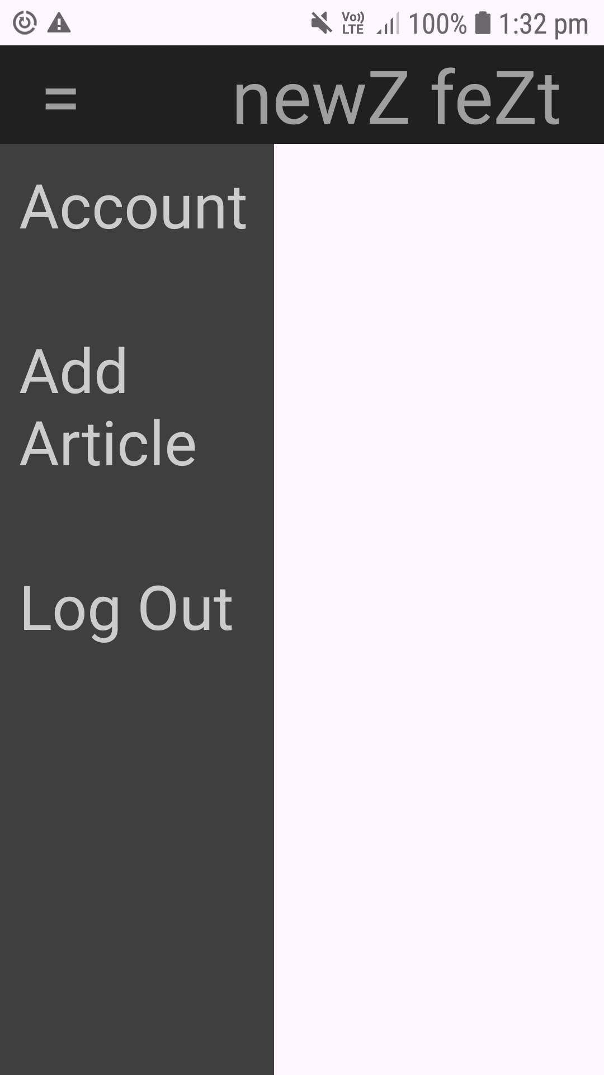

1. Write a Program to display the list of sensors supported by the mobile device.

Activity_main.xml

package com.example.mad_playground;  
  
import android.content.Intent;  
import android.net.Uri;  
import android.os.Bundle;  
import android.util.Log;  
import android.view.View;  
import android.widget.Button;  
import android.widget.EditText;  
  
import androidx.appcompat.app.AppCompatActivity;  
  
public class MainActivity extends AppCompatActivity {  
 String LifeCycle = "My Main Activity LifeCycle";  
 @Override  
 protected void onCreate(Bundle savedInstanceState) {  
 super.onCreate(savedInstanceState);  
 setContentView(R.layout.*activity_main*);  
 Log.*d*(LifeCycle, "onCreate() ---> called");  
 EditText num = findViewById(R.id.*num*);  
 Button button = findViewById(R.id.*button*);  
 button.setOnClickListener(new View.OnClickListener() {  
 @Override  
 public void onClick(View view) {  
 Intent intent = new Intent(getApplicationContext(), second_activity.class);  
 intent.putExtra("num", Integer.*parseInt*(*num*.getText().toString()));  
 startActivity(intent);  
 }  
 });  
 }  
}

MainActivity.java

package com.example.mad_playground;  
  
import android.content.Context;  
import android.hardware.Sensor;  
import android.hardware.SensorManager;  
import android.os.Bundle;  
import android.view.View;  
import android.widget.TextView;  
  
import androidx.appcompat.app.AppCompatActivity;  
  
import java.util.List;  
  
public class MainActivity extends AppCompatActivity {  
 private SensorManager mgr;  
 private TextView txtList;  
  
 @Override  
 protected void onCreate(Bundle savedInstanceState) {  
 super.onCreate(savedInstanceState);  
 setContentView(R.layout.*activity_main*);  
  
 *// SensorManager: create an instance of the sensor service class to access and listen to sensors* mgr = (SensorManager) getSystemService(Context.*SENSOR_SERVICE*);  
 txtList = findViewById(R.id.*sensorslist*);  
  
 List<Sensor> sensorList = mgr.getSensorList(Sensor.*TYPE_ALL*);  
 StringBuilder strBuilder = new StringBuilder();  
  
 for (Sensor s : sensorList) {  
 *// Sensor: create an instance of a specific sensor* strBuilder.append(s.getName()).append("\n");  
 }  
  
 txtList.setVisibility(View.*VISIBLE*);  
 txtList.setText(strBuilder.toString());  
 }  
}

OUTPUT:

